You have the right to determine your own best interests.

You have the right to exercise choice and control over decisions
that affect your life.

You will be involved in making decisions that affect you.

These decisions will be written in a document so we can keep
a record of your decisions and what you want to do.

We will support you to make decisions.

We will ensure that you have the right to be included in your community for work, fun, learning and relationships.

We will provide opportunities for you to play a valued role and have meaningful participation in your community.

We will enhance and protect your human rights, decision making, choice and control, safety and wellbeing, citizenship and quality of life.

Senses will also support you to:
• Understand relevant information;
• Retain or remember relevant information;
• Use or weigh up relevant information;
• Communicate the decision in words, gestures or by other means;
• Make individual choices, including your right to intimacy and sexual expression.

Your advocate can also assist you to make decisions.

Your advocate can also promote your wishes and preferences.

Your advocate can also enable you to access services and support required.

You will be told of the benefits and risks of your options and decisions.

You will be given time to think about options and seek help at
any time.

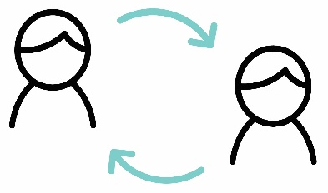

An interpreter can be provided.

For further information, please contact us follows:

1300 111 881

admingroup@senses.org.au

www.senses.org.au

Send a letter to the CEO,
Senses Australia,
PO Box 143, Burswood, WA, 6100

In person to any Senses Australia employee or
Volunteer

Complete a Feedback, Compliments and Complaints Form

